# Iot Journal : SLAM IoT-based Project using EKF, FastSLAM on Cloud using multiple clients.

Ashish Jacob Sam

B.Tech CSE

BCSE1605

ASET

A70405216032

Amity University Mumbai

## 1. Introduction

### SLAM

SLAM is a process by which a mobile robot can build a map of an environment and at the same time use this map to deduce it’s location. In SLAM both the trajectory of the platform and the location of all landmarks are estimated on-line without the need for any a priori knowledge of location.

At a time instant k, the following quantities are defined:​

• xk : The state vector describing the location and orientation of the vehicle.​

• uk : The control vector, applied at time k−1 to drive the vehicle to a state xk at time k.​

• mi : A vector describing the location of the i th landmark whose true location is assumed time invariant.​

• zik : An observation taken from the vehicle of the location of the i-th landmark at time k. When there are multiple landmark observations at any one time or when the specific landmark is not relevant to the discussion, the observation will be written simply as zk ​

### IoT

The Internet of Things (IoT) is a system of interrelated computing devices, mechanical and digital machines, objects, animals or people that are provided with unique identifiers (UIDs) and the ability to transfer data over a network without requiring human-to-human or human-to-computer interaction.​

* Consumer Applications​
* Commercial Applications​
* Industrial Applications​
* Infrastructure Applications​
* Millitary Applications​

### Kalman Filter

* Kalman Filter is a mathematical concept of filtering out the errors.​
* It is a probablistic model which works to reduce the error as much as possible.​
* It is an iterative mathematical process that uses a set of equations and consecutive data inputs to estimate the values we are interested in associated with the object.
* Kalman Filter helps to get predictions closer to the actual values.​
* It is a good option to predict Linear functions.​
* For the SLAM-process, distances can be predicted using Kalman Filter​

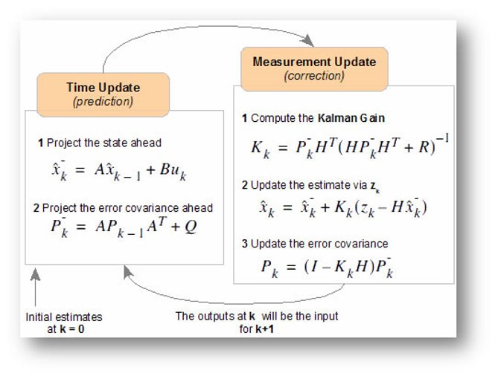

### Extended Kalman Filter(EKF)

* For mesurements invloving angles, the function is non-linear. We need another filter for these values.​
* Extended Kalman Filter is used for these non-linear functions.

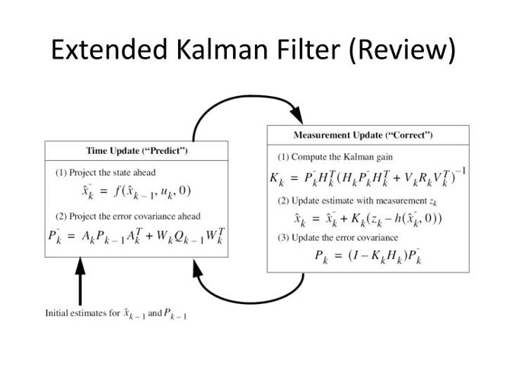

### FastSLAM

FastSLAM decomposes the SLAM problem into a robot localization problem, and a collection of landmark estimation problems that are conditioned on the robot pose estimate.

FastSLAM samples the path using a particle ﬁlter. Each particle has attached its own map, consisting of N extended Kalman ﬁlters. Formally, the m-th particle S[m]t contains a path st,[m] along with Gaussian N landmark estimates, described by the mean µ[m]n,t and covariance Σ[m]n,t​

The pose s[m]t is sampled in accordance to the prediction arising from the motion command ut . It does not consider the measurement zt acquired at time t; instead, the measurement is incorporated through resampling. ​

## 2. Literature Survey

| S.no​ | Paper Title​ | Authors​ | Date of Paper​ | Work Done​ | Advantages​ | Disadvanteges​ | Opinion​ |
| --- | --- | --- | --- | --- | --- | --- | --- |
| 1​ | FastSLAM: A Factored Solution to the Simultaneous Localization and Mapping Problem​  ​ | Michael Montemerlo, Sebastian Thrun, Daphne Koller and Ben Wegbreit​ | 2002​ | Solves the SLAM problem more efficiently than the EKF-SLAM​ | Gives the complexity of O(M log K) as compared to O(K2) of EKF​ | The given approach uses high storage in form of Tree data structure.​ | A factored approach for implementation of SLAM​ |
| 2​ | FastSLAM 2.0: An Improved Particle Filtering Algorithm for Simultaneous​  Localization and Mapping that Provably Converges​ | Michael Montemerlo, Sebastian Thrun, Daphne Koller and Ben Wegbreit​ | 2003​ | This paper describes a modiﬁed FastSLAM algorithm that​  is uniformly superior to the FastSLAM algorithms.​ | The optimization in running time are superior​ | It takes up more space as the data is refactored​ | Shows the superiority of FastSLAM 2.0 over its predecessor​ |
| 3​ | Simultaneous Localisation and Mapping (SLAM): Part I The Essential Algorithms​  ​ | Hugh Durrant-Whyte, Fellow, IEEE, and Tim Bailey​ | 2006​ | Review of SLAM algorithms up to that point​ | Shows FastSLAM as the preferred method of approach as the computation of it is better compared to the rest.​ | Does not give much details on the implementation in the case of complex environment​ | Discussed SLAM problem definition and following algorithms:​  Extended Kalman Filter​  Rao-Backwellised Filter​ |
| 4​ | A Tutorial on Graph-Based SLAM​ | Giorgio Grisetti Rainer Kümmerle Cyrill Stachniss Wolfram Burgard​ | 2009​ | Presents a tutorial of Grpah-based SLAM​ | It is easy to implement in a simple 2D and 3D based mapping by building a dataset​ | For sufficiently large environment, the constructed Graph requires too much resources.​ | Discussed implementation of SLAM using Graph-Based approach​ |
| 5​ | Cloud-based Parallel Implementation of SLAM for Mobile Robots​ | Supun Kamburugamuve, Hengjing He, Geoffrey Fox, David Crandall ​ | 2016​ | Setting up a client bot sending parallel data to Cloud​ | The mobile robot does not require much resources as SLAM processing is done by the server​ | Does not optimise the problem in any way. The server still has to process along with send/recieve data​ | Implementation of IoT-based SLAM to upload data and process it​ |
| 6​ | FastSLAM 2.0 tracking and mapping as a Cloud Robotics service​ | Shimaa S Ali,​  Abdallah Hamaad,​  Adly S. Tag Eldien​ | 2017​ | The SLAM problem is divided into 2 parallel tasks. Mapping and localization are concurrently operated in the cloud​ | The results show that the computational cost of the tracking process in ​  the Cloud is reduced by 83.6% as compared to its execution on a single robot platform.​ | The setup reqirements are very High as it uses Big Data​ | Discussed implementation of SLAM using Graph-Based approach​ |
| 7​ | Cloud-based map alignment strategies​  for multi-robot FastSLAM 2.0​ | Shimaa S Ali,​  Abdallah Hamaad,​  Adly S. Tag Eldien​ | 2018​ | It proposes an efficient architecture for cloud-based cooperative simultaneous​  localization and mapping to parallelize its complex steps via the multiprocessor (computing nodes) and free the robots​  from all of the computation efforts. ​ | This work improves the map alignment part using hybrid combination​  strategies, random sample consensus, and inter-robot observations to exploit fully their advantages.​ | Dependance of clients on servers. The architecture runs on Big-Data and requires lots of resources​ | Improvements on Client-Server architecture for SLAM process.​ |

## Research Gaps

* Most of these research work hinges on the Server doing the full process. The clients are reduced to just being a remote sensors.​
* There is almost no information processing to be done by the clients before sending to the server.​
* This makes the client-machines completly dependant on the server

## Problem Statement

* In this project, we intend to utilize the algorithms and set it for multiple bots(clients) sending data to a single server.​
* The objective is to generate a reliable Map of the scouted area.​
* The generated Map is somewhat processed in the client machines as well.​
* The client should do some data processing on its own in case it is disconnected from the Server.​

## Objective of the work​

* To implement a framework for SLAM and generate a map of the scouted area.​
* To setup multiple clients to gather information and send the data to a server.​
* To make the clients to preprocess the data so that client itself can retain and use this data.​